

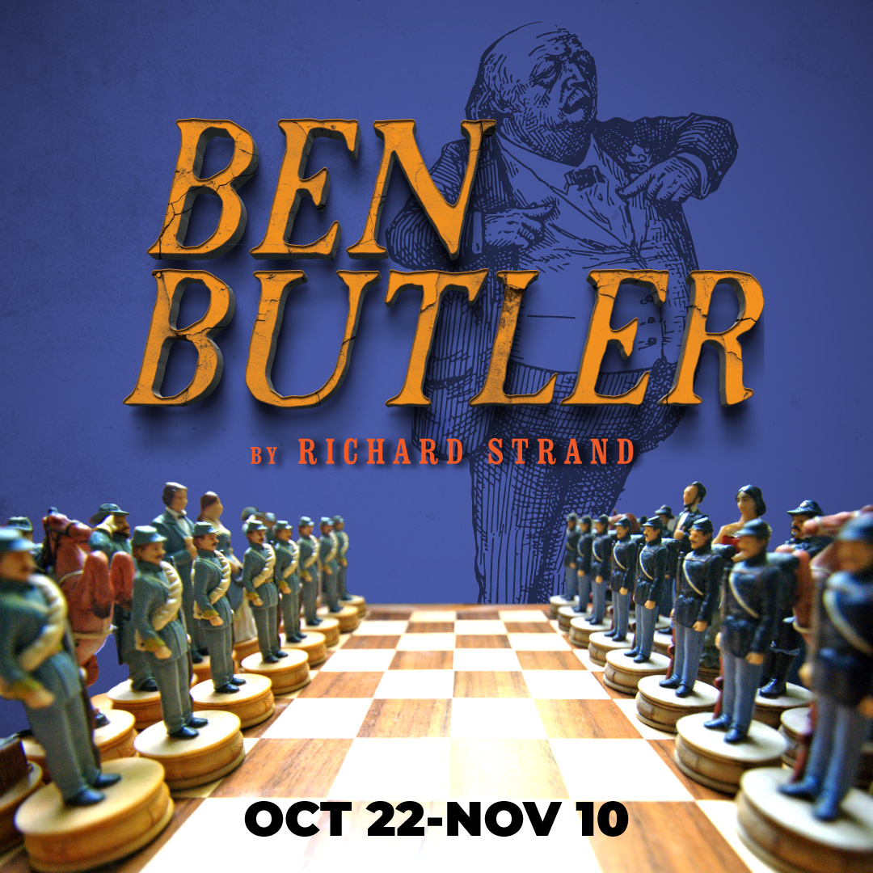

Inspired by true events, Ben Butler tells a Civil War tale with surprising silliness. The story begins when a runaway slave arrives at Fort Monroe and demands sanctuary forcing the newly installed Gen. Benjamin Butler to face an impossible moral dilemma: follow the law or alter the course of U.S. history. Part history lesson, part farce, this “what if” play set at the dawn of the Civil War is inspired by a technicality that fundamentally changed the course of the War.

**The play is a swift-moving battle of wit and wordplay that is “simultaneously thought-provoking and sidesplitting.” –TheatreMania**

**TYPE IN YOUR GROUP INFORMATION HERE**