

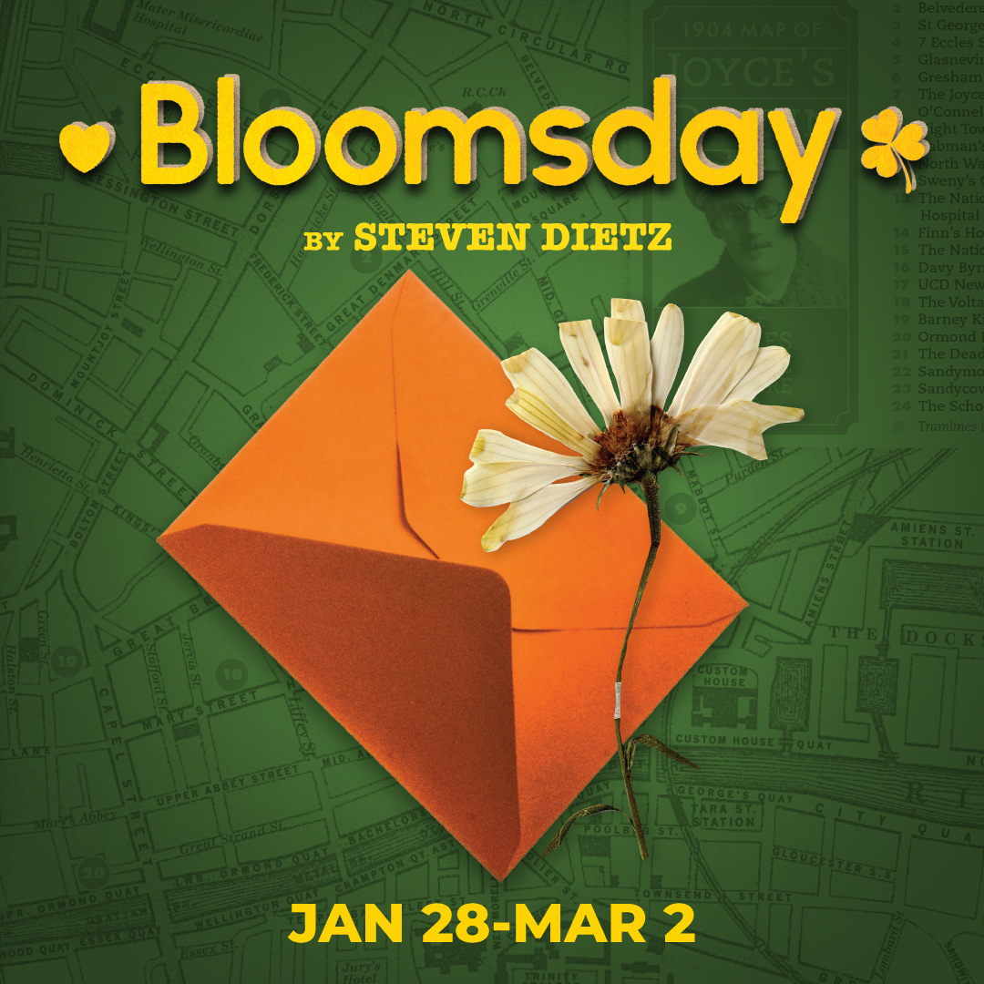

In this touching time-travel love story from the author of “Becky’s New Car,” Robert returns to Dublin to reunite with the woman who captured his heart thirty-five years earlier. Dancing backward through time, Robert and Cait retrace their steps and discover their younger selves – Robbie and Caithleen. Told with wit, humor, and heartache, Bloomsday is a buoyant, moving story about making the most of the present before it becomes the past.

**BLOOMSDAY gives us a funny, touching and stark look at what it is to be in love no matter what stage of life you’re in.” —BroadwayWorld.**

**TYPE IN YOUR GROUP INFORMATION HERE**