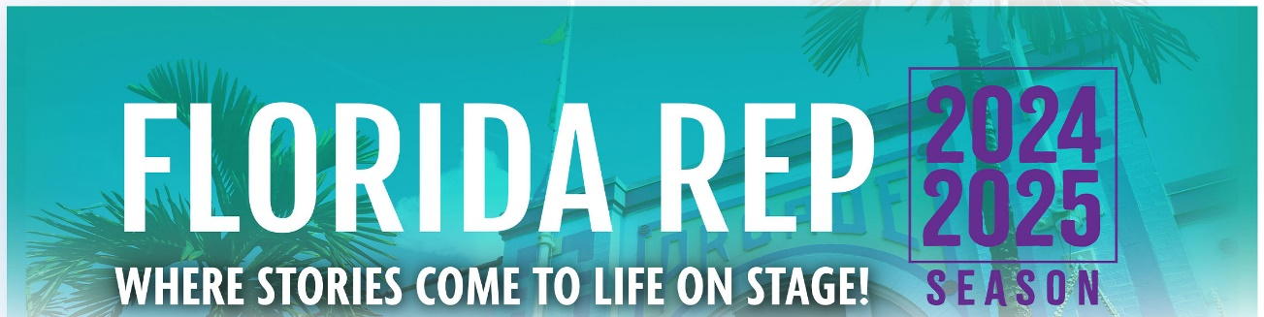

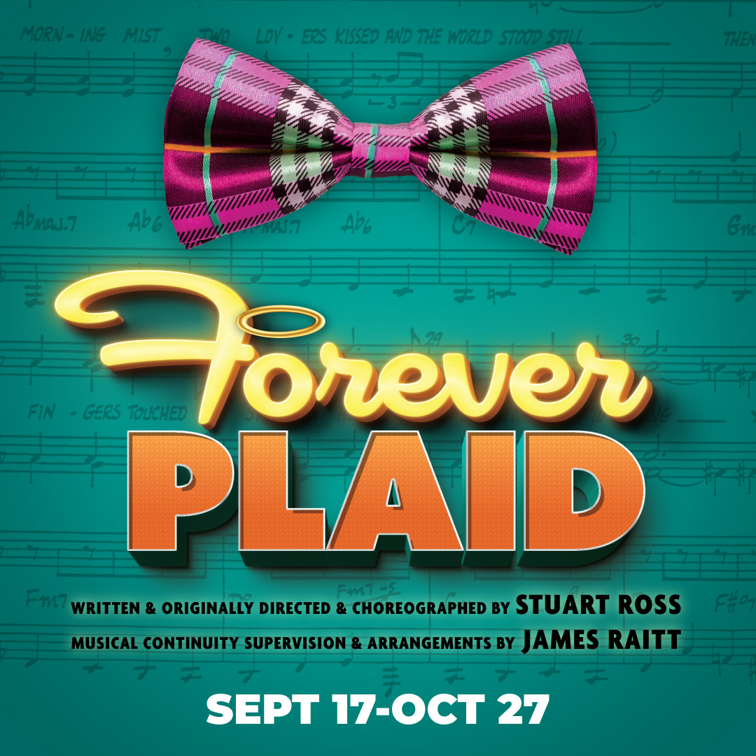

Celebrate the music of the 1950s in this nostalgic, funny – and heavenly – musical revue! When tragedy strikes on the way to their first big gig, four pals Sparky, Smudge, Jinx, and Frankie, united by their love of music, get to perform a show-stopping concert in the afterlife. This smash hit musical joyride is a loving, goofy retro story about second chances. It’s filled with barbershop harmonies and pitch-perfect melodies, with swing, boogie-woogie, Latin, and Calypso music styles, and timeless hits such as, “Three Coins in the Fountain,” “Moments to Remember,” “Sixteen Tons,” and more!

**“A MARVELOUS RETRO HIT PARADE.” – Chicago Sun-Times**

**TYPE IN YOUR GROUP INFORMATION HERE**