

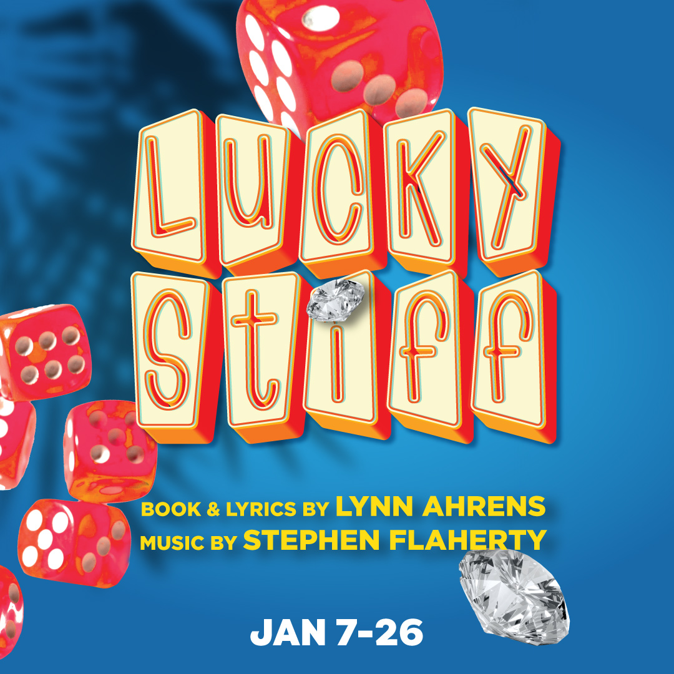

The stage is set for hilarity in this off-beat musical-murder-mystery-farce! When hapless English shoe salesman, Harry Witherspoon, learns he’s heir to a distant uncle’s fortune of rare diamonds, he’ll do anything to get his hands on the jewels – even if it means wheeling his uncle’s corpse around Monte Carlo for one last vacation. Meanwhile, a host of shady characters (including a jilted mob wife, a dogged do-gooder, and an optometrist) are hot on his trail!

**“A merry mix of mayhem and misadventure.” – Broadway World**

**TYPE IN YOUR GROUP INFORMATION HERE**