

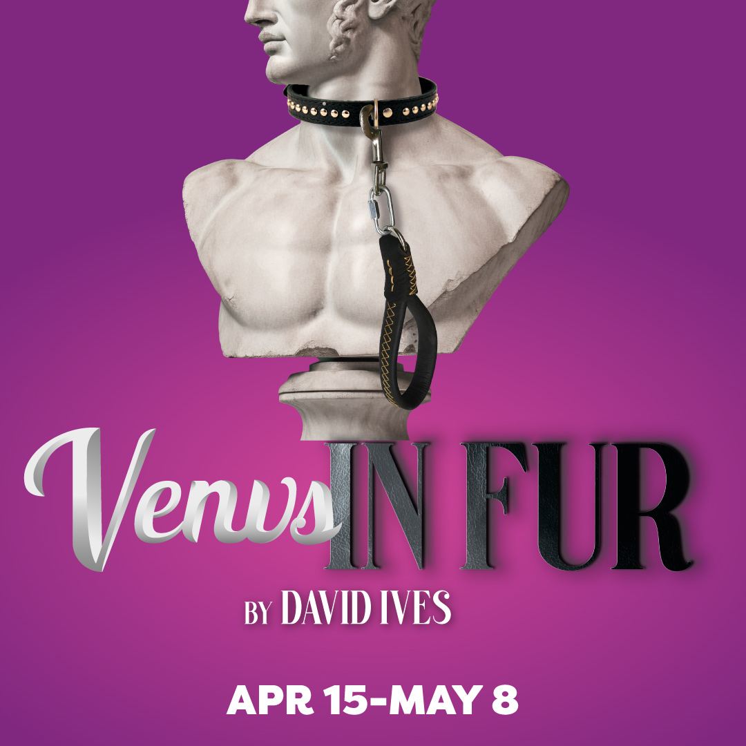

Sexy, provocative, and witty, Venus in Fur turns up the heat on sexual power play and is sure to charm and mesmerize. When Vanda arrives several hours late to her audition for a play based on a nineteenth-century erotic novel, the director is less than impressed. Vanda’s masterful performance, however, flips the script and the audition turns into a tango for dominance between actress and director.

**“…a seriously smart and funny stage seminar on the destabilizing nature of sexual desire: vanilla-flavored, kink-festooned, or anything in between.” – The New York Times**

**TYPE IN YOUR GROUP INFORMATION HERE**